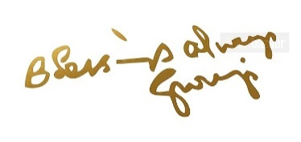

THIS LOGO YOU CAN GET HD ON NET

**Terms and Privacy Policy:** At Shree Astrotalks, we're here to empower you with positive guidance through our services like the Numeroscope and astrology predictions. While we aim for accuracy, please understand that astrology and numerology offer interpretations and potential paths. Our services are meant to uplift you personally, so cherish them as tools for growth. It is entirely your decision whether to follow or disregard the predictions and remedies provided. Your privacy is paramount, and we collect your information solely to enhance your experience. Rest assured, your data is protected and never shared without your consent. You have the power to opt out of promotional communications anytime. As we evolve, so may our policies, but our commitment to your well-being remains constant. If you have any questions, we're here to help Please contact us by mail at [astrotalksshree@gmail.com](mailto:astrotalksshree@gmail.com)

SERVICES 1 LINK <https://superprofile.bio/vp/670c18d9d993b30013555b0d>

SERVICES 2 LINK <https://superprofile.bio/vp/66cfa4430b9337001372b30b>

SERVICES 3 LINK <https://superprofile.bio/vp/x1_sSJXT>

SERVICES 4 WHATS AAP